USE A WORD FROM THE BOX

merchandise, people, furniture
by land, goods, by sea, travel, by air,

- Means of transportation are classified into _______________________, ____________________________, __________________________.
- Means of transportation allow ___________________ to ___________________________.
- They can also transport_________________________, ________________________, _______________________________.

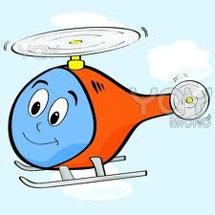
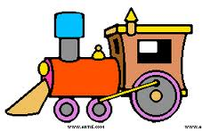
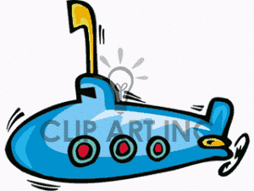
car bus train
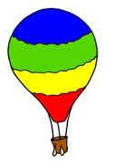
Hot air balloon airplane helicopter
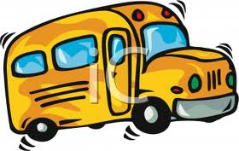
Bus van lorry
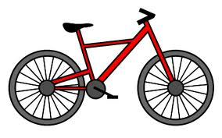
Motorcycle train bike
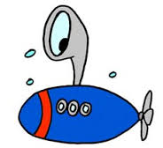
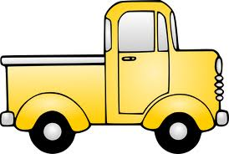
Submarine boat chip
Bus lorry van
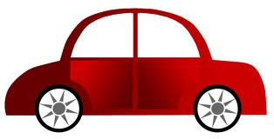
Lorry car van
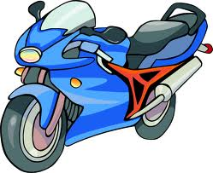
Bike car motorcycle
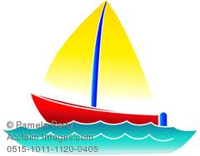
Ship submarine boat
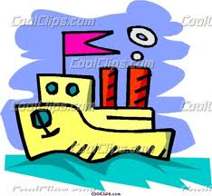
Boat ship submarine
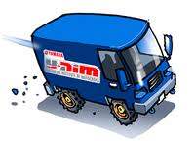
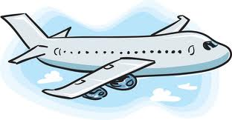
Helicopter airplane hot air balloon

Lorry van bike
Helicopter airplane hot air balloon

